Product.cs
using System;
using System.Collections.Generic;
using System.Text;

namespace App1.Models
{
public class Product
{
public int ProductId { get; set; }

public string Name { get; set; }

public decimal Price { get; set; }

public int Stock { get; set; }
}
}
Category.cs
using System;
using System.Collections.Generic;
using System.Text;

namespace App1.Models
{
public class Category
{
public int CategoryId { get; set; }

public string CategoryName { get; set; }
}
}
AppContextDb.cs
using System;
using System.Collections.Generic;
using System.Text;

using Microsoft.EntityFrameworkCore;
using App1.Models;

namespace App1.Data
{
public class AppDbContext : DbContext
{
public AppDbContext(DbContextOptions<AppDbContext> options)
: base(options)
{
}

public DbSet<Product> Products { get; set; }

public DbSet<Category> Categories { get; set; }
}
}
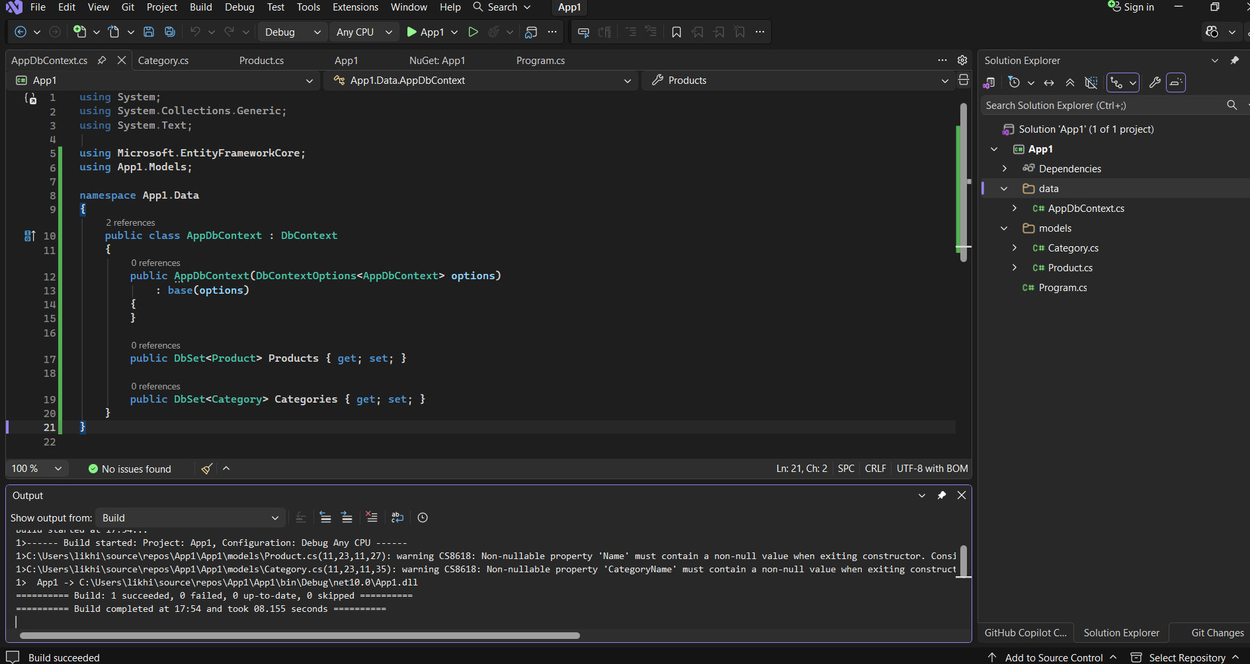

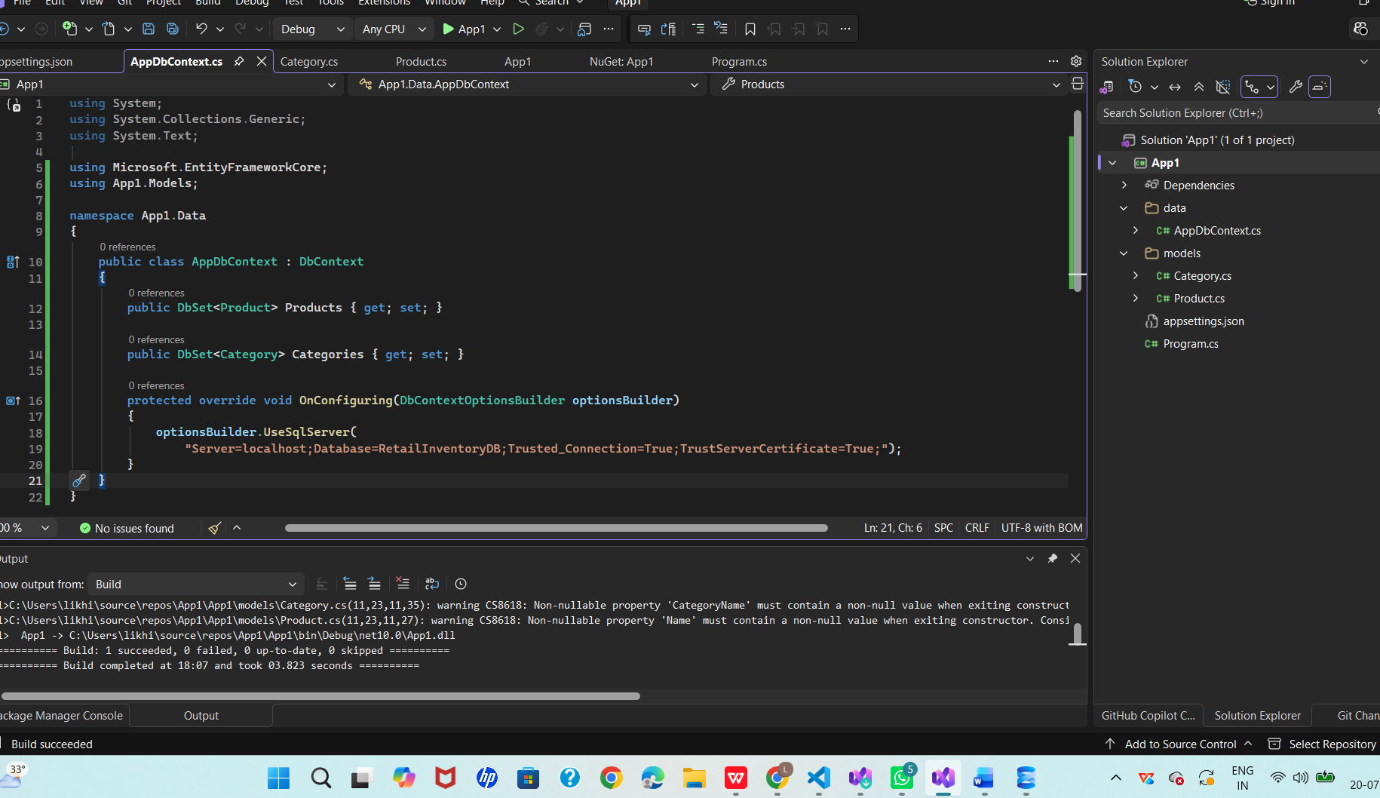
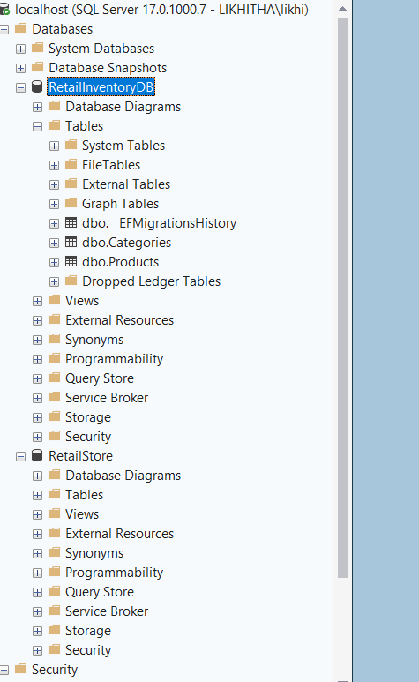
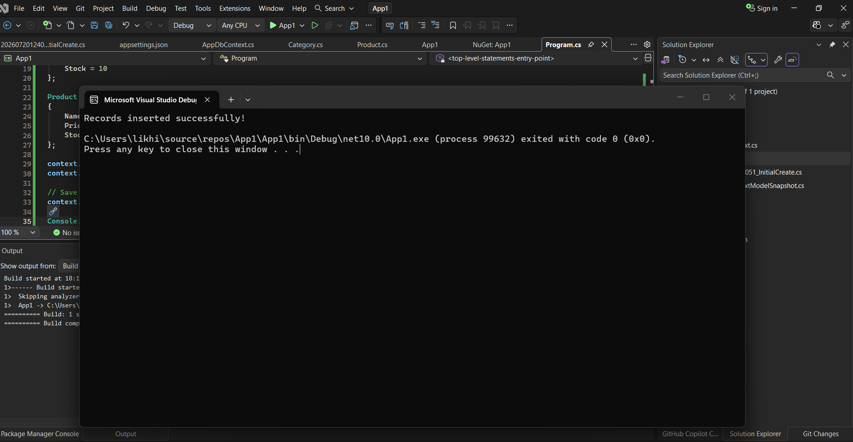
dbo.Products:
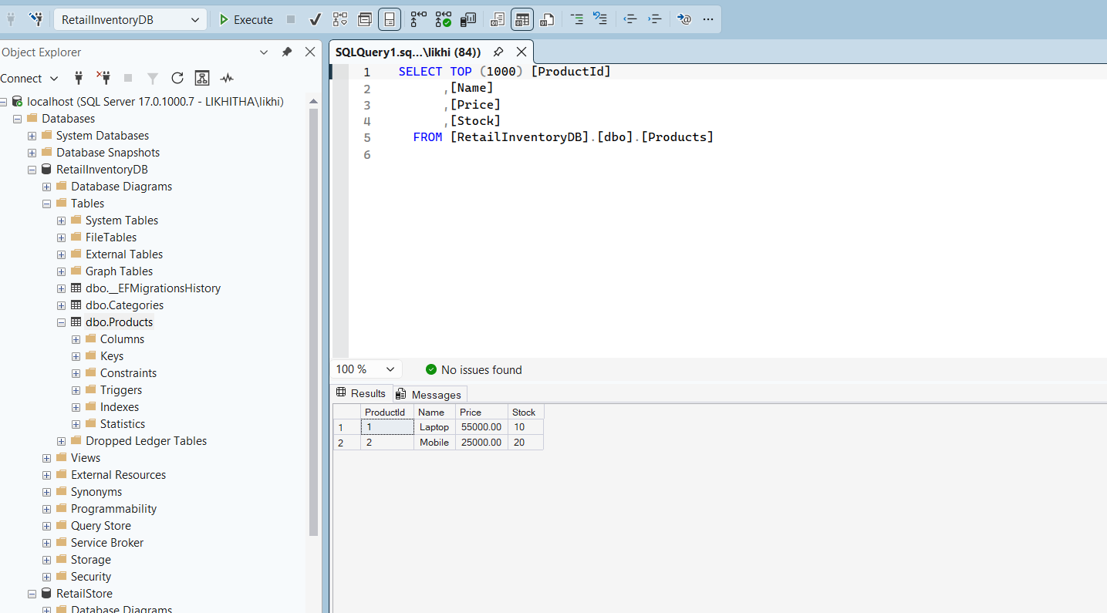
dbo.Categories:
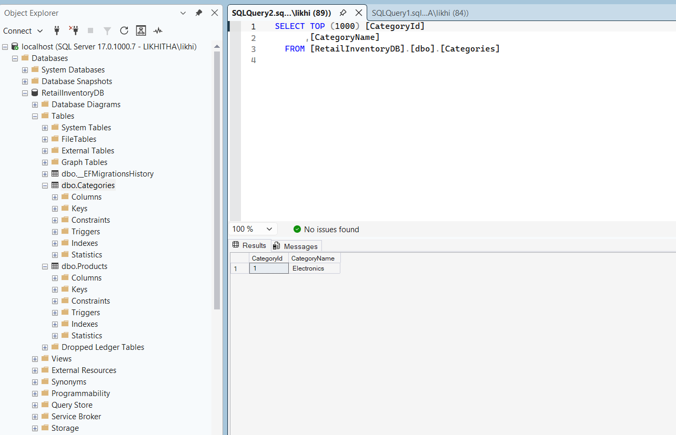

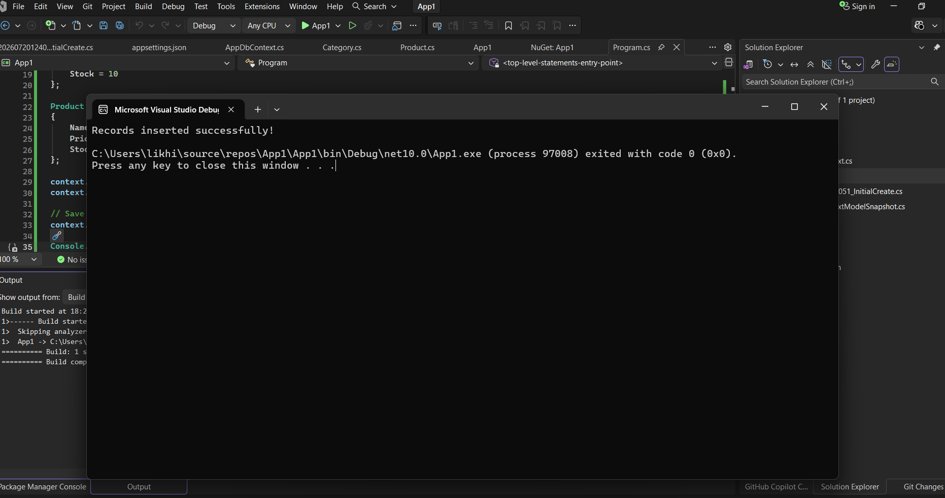
Dbo.products:
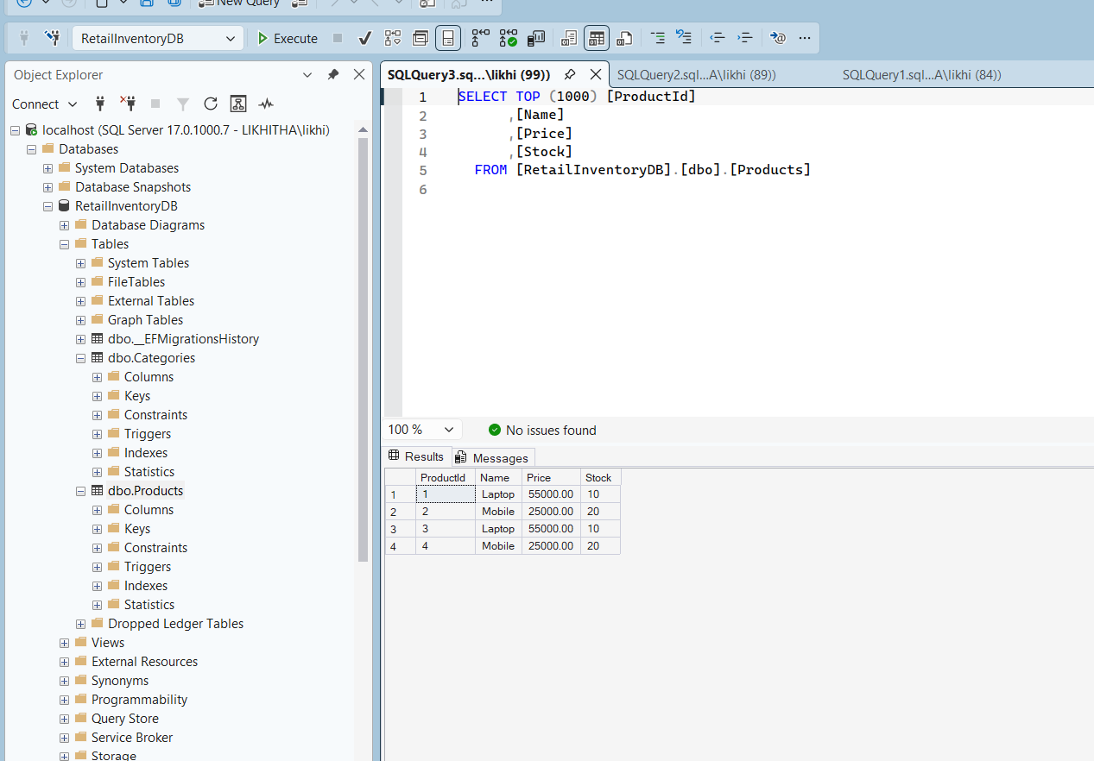
Dbo.categories:
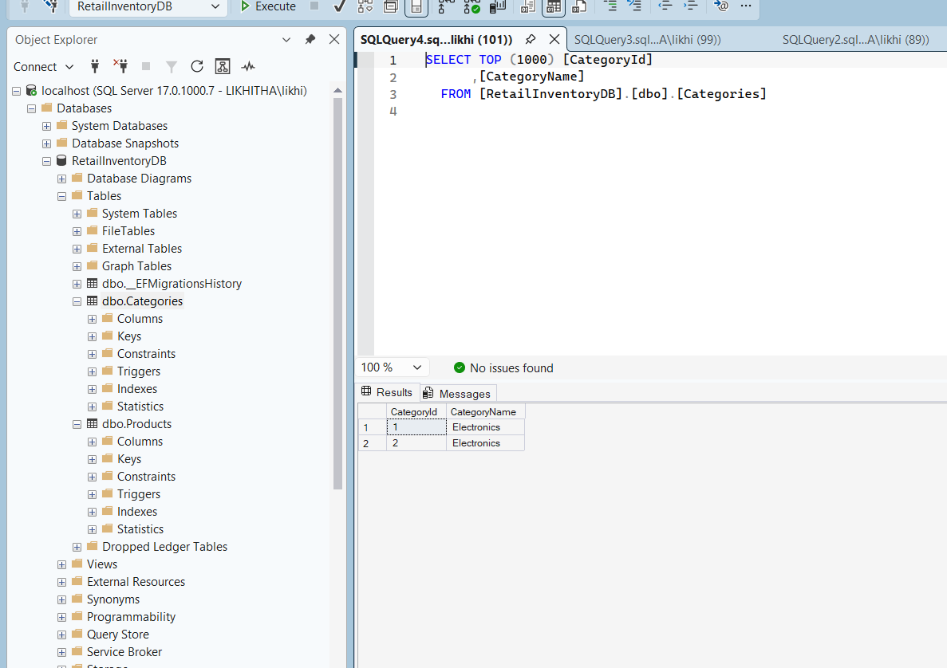
Product updation:
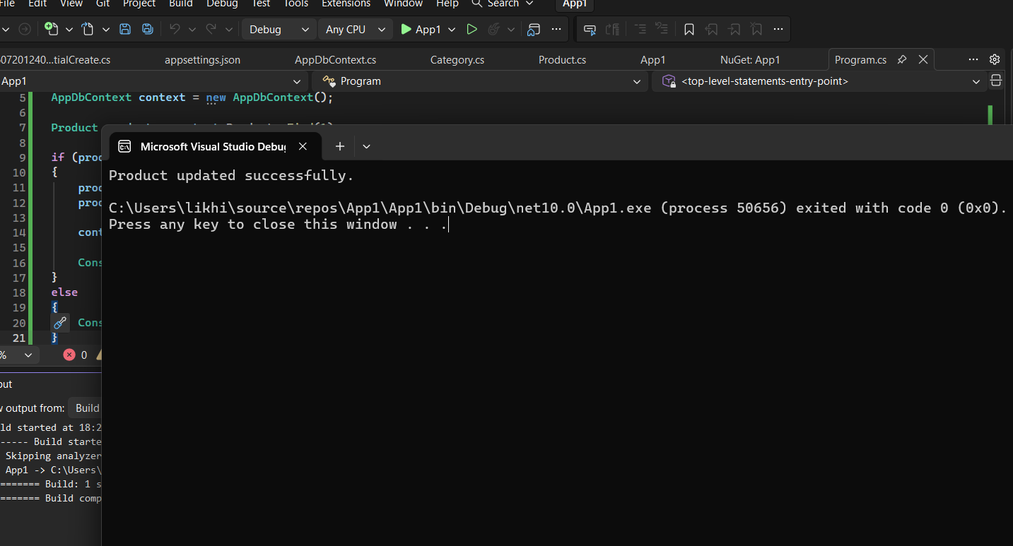
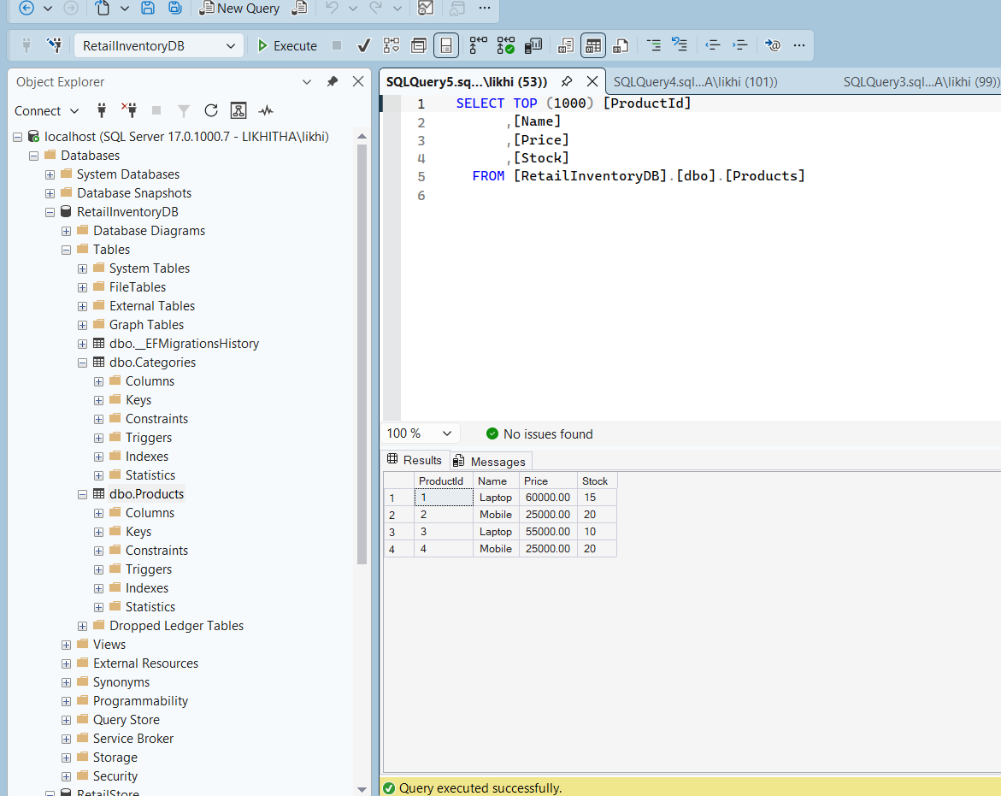
Delete product:
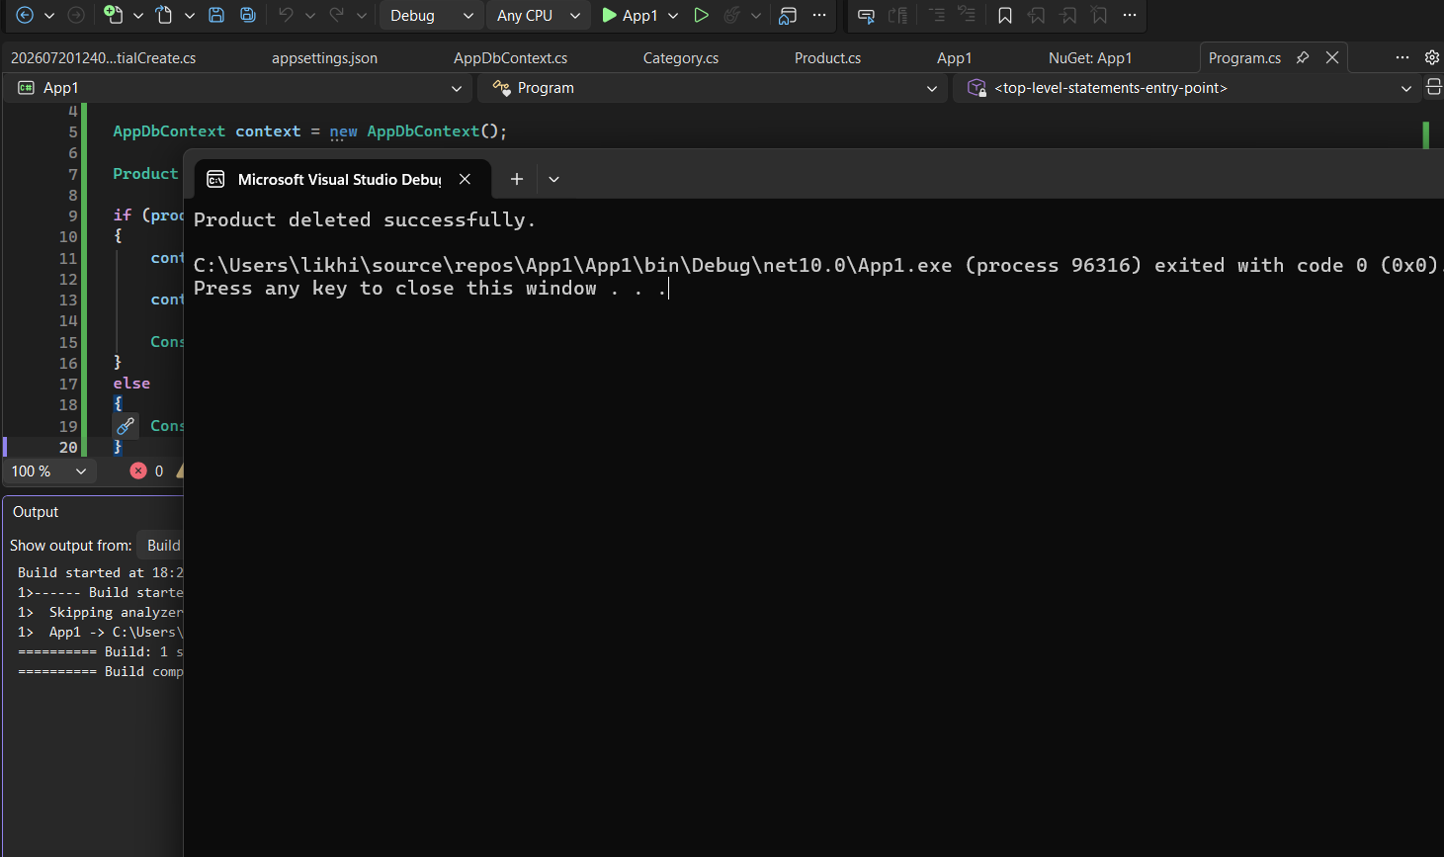
Deleted successfully:
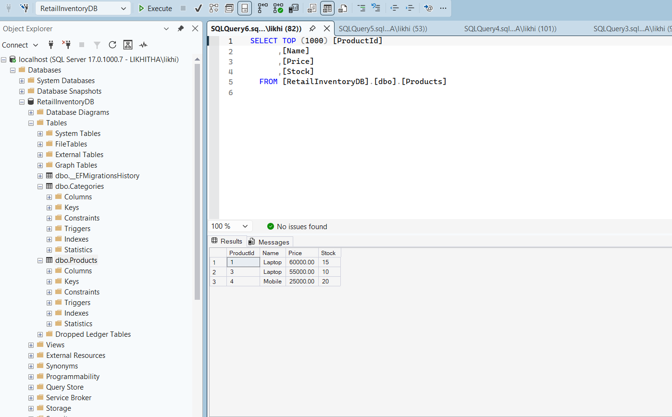
Delete category:
using System;
using App1.Data;
using App1.Models;

AppDbContext context = new AppDbContext();

Category category = context.Categories.Find(1);

if (category != null)
{
context.Categories.Remove(category);

context.SaveChanges();

Console.WriteLine("Category deleted successfully.");
}
else
{
Console.WriteLine("Category not found.");
}

Retrieve All Products
using System;
using System.Linq;
using App1.Data;

AppDbContext context = new AppDbContext();

var products = context.Products.ToList();

foreach (var product in products)
{
Console.WriteLine($"{product.ProductId} {product.Name} {product.Price} {product.Stock}");
}
Where()
Retrieve products with price greater than 30000.
using System;
using System.Linq;
using App1.Data;

AppDbContext context = new AppDbContext();

var products = context.Products
.Where(p => p.Price > 30000)
.ToList();

foreach (var product in products)
{
Console.WriteLine($"{product.Name} - {product.Price}");

Select()
Retrieve only product names.
using System;
using System.Linq;
using App1.Data;

AppDbContext context = new AppDbContext();

var names = context.Products
.Select(p => p.Name)
.ToList();

foreach (var name in names)
{
Console.WriteLine(name);
}
Output
Laptop
Mobile

OrderBy()
using System;
using System.Linq;
using App1.Data;

AppDbContext context = new AppDbContext();

var products = context.Products
.OrderBy(p => p.Price)
.ToList();

foreach (var product in products)
{
Console.WriteLine($"{product.Name} {product.Price}");
}
OrderByDescending()
using System;
using System.Linq;
using App1.Data;

AppDbContext context = new AppDbContext();

var products = context.Products
.OrderByDescending(p => p.Price)
.ToList();

foreach (var product in products)
{
Console.WriteLine($"{product.Name} {product.Price}");
}

Count()
using System;
using App1.Data;

AppDbContext context = new AppDbContext();

Console.WriteLine("Total Products = " + context.Products.Count());
Max()
using System;
using System.Linq;
using App1.Data;

AppDbContext context = new AppDbContext();

Console.WriteLine("Highest Price = " + context.Products.Max(p => p.Price));
Min()
using System;
using System.Linq;
using App1.Data;

AppDbContext context = new AppDbContext();

Console.WriteLine("Lowest Price = " + context.Products.Min(p => p.Price));
um()
using System;
using System.Linq;
using App1.Data;

AppDbContext context = new AppDbContext();

Console.WriteLine("Total Stock = " + context.Products.Sum(p => p.Stock));

